

FACULTY OF INFORMATION & COMMUNICATION TECHNOLOGY
PROG 102– PRINCIPLE OF SOFTWARE ENGINERRING
Title : Final Project
Due Date : Week 11
Lecturer/Examiner : Mr. Santigue F. Kamara
Class : BICT 1201
Semester : 2/2
Group : 4
NAME | STUDENT.ID | SIGNATURE
Christopher S. Conteh | 905005712
Sulaiman S.B Munda | 905005468
Salem A.Solomon S.Samura | 905005424
Academic Honesty Policy Statement
I/We, hereby attest that contents of this attachment are my own work. Referenced works, articles, art, programs, papers or parts thereof are acknowledged at the end of this paper. This includes data excerpted from CD-ROMs, the Internet, other private networks, and other people’s disk of the computer system
Student’s Signature: Date: 23rd /06/2026
LECTURER’S COMMMENTS/GRADE:

Remark
DATE :
TIME:
RECIEVER’S NAME:
Table of contents
INTRODUCTION 3
Background of the Study 3
Problem Statement 4
Aim of the Project 4
Objectives of the Project 5
Research Questions 5
Significance of the Study 6
System Users 7
Resident 7
Waste Collector 7
Administrator 7
System Features 7
System Architecture Design 8
Software Development Methodology 9
Scope of the Project 10
Limitations of the Project 10
Sustainable Development Goal (SDG) Alignment 11
Conclusion 12

INTRODUCTION

Background of the Study
Waste management is an essential aspect of environmental sustainability and public health. As urban populations continue to grow, the generation of solid waste has increased significantly, creating challenges for local authorities and communities. Improper disposal of garbage contributes to environmental pollution, blocked drainage systems, flooding, unpleasant odors, and the spread of diseases.
In many communities, waste management processes are still handled manually. Residents often find it difficult to report garbage accumulation, illegal dumping, or missed waste collections. Furthermore, waste management authorities may experience delays in receiving reports, assigning waste collectors, and monitoring collection activities. These challenges result in inefficient waste management practices and reduced environmental cleanliness.
The advancement of information and communication technology provides opportunities to improve waste management systems through digital solutions. A Smart Garbage Management System can facilitate communication between residents, waste collectors, and administrators by providing a centralized platform for reporting, tracking, and managing waste collection activities.
This project proposes the development of a Smart Garbage Management System (SGMS) that enables residents to report garbage-related issues, allows waste collectors to manage collection tasks, and provides administrators with tools for monitoring and decision-making. The system aims to improve waste management efficiency, environmental sanitation, and community well-being.

Problem Statement
Poor waste management remains a significant challenge in many communities. Residents often encounter situations where garbage accumulates in public areas, drainage channels become blocked by waste, and collection services are delayed or ineffective.
The existing methods of reporting waste-related issues are largely manual and inefficient. Residents may have to physically visit local authorities or rely on informal communication channels to report problems. As a result, reports may be delayed, lost, or ignored. Waste collectors may also face challenges in receiving timely information regarding collection assignments, while administrators may lack effective tools for monitoring and coordinating waste management activities.
These challenges contribute to environmental pollution, public health risks, and reduced quality of life. Therefore, there is a need for a digital solution that streamlines waste reporting, collection management, and monitoring processes.

Aim of the Project
The aim of this project is to design and develop a Smart Garbage Management System that improves waste management processes by enabling efficient reporting, monitoring, and coordination of garbage collection activities.

Objectives of the Project
General Objective
To develop a Smart Garbage Management System that enhances waste management efficiency and promotes environmental sustainability.
Specific Objectives
- To provide residents with a platform for reporting garbage disposal issues.
- To enable residents to upload photographs as evidence of waste-related problems.
- To allow waste collectors to receive and manage assigned collection tasks.
- To provide administrators with tools for monitoring waste management activities.
- To generate notifications and status updates for users.
- To improve communication between residents, waste collectors, and administrators.
- To contribute to cleaner and healthier communities.

Research Questions
The study seeks to answer the following questions:
- How can technology improve waste management processes within communities?
- How can residents effectively report garbage-related issues?
- How can waste collectors receive and manage collection assignments efficiently?
- How can administrators monitor waste management activities in real time?
- How can a Smart Garbage Management System contribute to environmental sustainability?

Significance of the Study
The Smart Garbage Management System is expected to benefit various stakeholders.
Residents
The system provides residents with a convenient platform for reporting waste-related issues and tracking the progress of their reports.
Waste Collectors
The system enables waste collectors to receive assignments efficiently and update collection status in real time.
Administrators
The system assists administrators in monitoring waste management activities, assigning collection tasks, and generating reports for decision-making purposes.
Communities
The project promotes environmental cleanliness, reduces pollution, and improves public health within communities.
Researchers and Students
The project serves as a reference for future studies and software development projects related to environmental management systems.

System Users
The Smart Garbage Management System consists of three primary users:

Resident
Residents are responsible for reporting garbage-related issues within their communities. They can create accounts, submit reports, upload photo evidence, view report status, and receive notifications regarding collection progress.

Waste Collector
Waste collectors are responsible for handling assigned waste collection tasks. They can access assigned reports, update collection status, and mark tasks as completed.

Administrator
Administrators manage the overall system. Their responsibilities include managing users, assigning waste collectors, monitoring reports, generating statistics, and ensuring smooth system operations.

System Features
The Smart Garbage Management System provides the following features:
Resident Features
- User registration and login
- Garbage report submission
- Photo upload functionality
- Report status tracking
- Notification management
Waste Collector Features
- View assigned reports
- Update collection status
- Mark collection tasks as completed
Administrator Features
- User management
- Report monitoring

System Architecture Design
The system follows a Three Tier Architecture consisting of:
Presentation Layer
This layer serves as the user interface through which residents, waste collectors, and administrators interact with the system.
Business Logic Layer
This layer handles user management, report processing, validation, notifications, and analytics.
Database Layer
This layer stores user information, garbage reports, notifications, and collection status records.
The three-tier architecture improves maintainability, scalability, security, and system performance.
Database Design
The system database consists of the following entities:
- User
- Resident
- Waste Collector
- Garbage Report
- Notification
These entities are connected through relationships that support report submission, task assignment, status updates, and notification management.

Software Development Methodology
The project adopts the Waterfall Software Development Life Cycle (SDLC) model. The stages include:
- Requirement Gathering
- System Analysis
- System Design
- Development
- Testing
- Deployment
- Maintenance
The Waterfall model was selected because the project requirements were clearly defined from the beginning, allowing a structured and systematic development process.

Scope of the Project
The scope of this project is limited to the design and development of a Smart Garbage Management System for managing waste reporting and collection activities.
The system will provide the following functionalities:
- User registration and authentication
- Garbage report submission
- Photo upload functionality
- Waste collector assignment
- Collection status updates
- Notification management
- Administrative monitoring and reporting
The project focuses on software design, system analysis, and prototype development. It does not include the deployment of physical waste collection equipment or smart waste bins.

Limitations of the Project
The project is subject to the following limitations:
- The system prototype may not include real-time GPS tracking functionality.
- The system will operate as a prototype and may not be fully integrated with municipal waste management authorities.
- Internet connectivity is required for users to access the system.
- The project does not include implementation of hardware-based waste monitoring devices.
Despite these limitations, the system demonstrates how digital technologies can improve waste management operations.

Sustainable Development Goal (SDG) Alignment
This project aligns with Sustainable Development Goal 3 (Good Health and Well-being) and 11: Sustainable Cities and Communities.
The goal aims to make Good Health and Well-Being by helping reduce health risks associated with poor waste disposal practices.
And make cities and human settlements inclusive, safe, resilient, and sustainable. Effective waste management plays a critical role in achieving this objective by reducing environmental pollution, improving sanitation, and promoting public health.
The Smart Garbage Management System supports this goal by providing a digital platform that enhances waste management efficiency, encourages community participation, and contributes to cleaner urban environments.

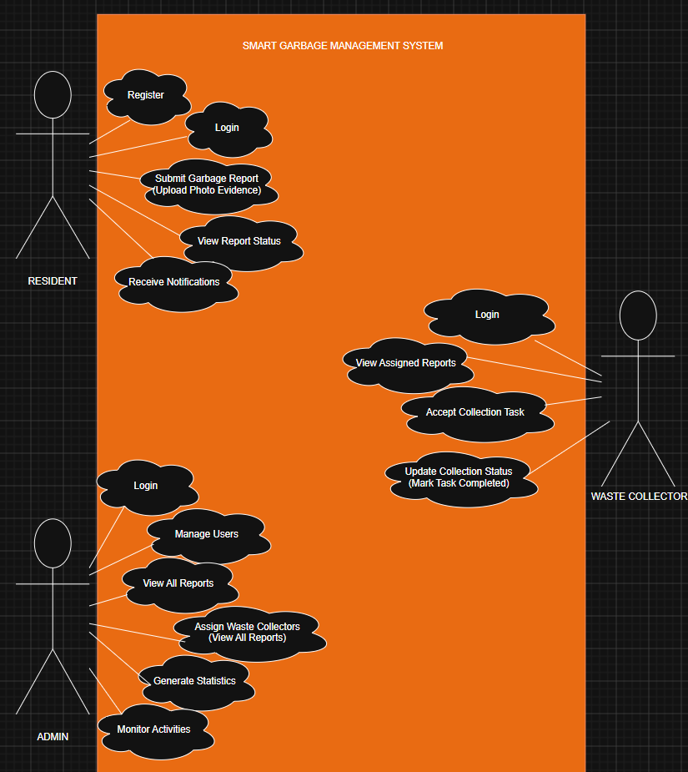

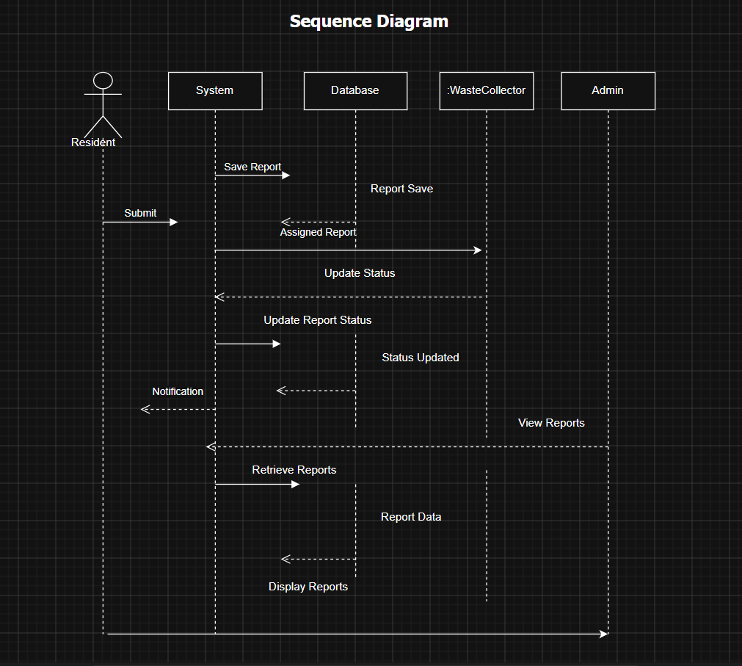

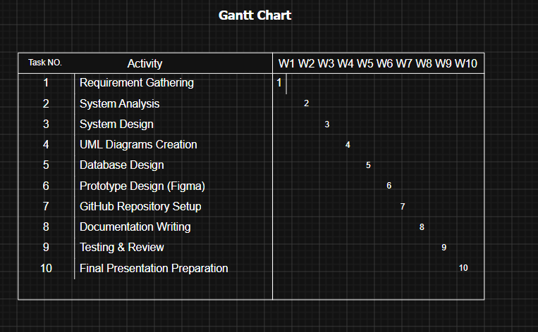

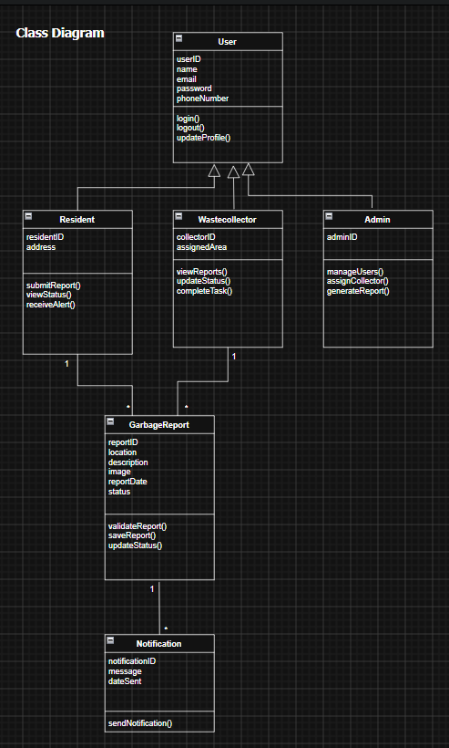

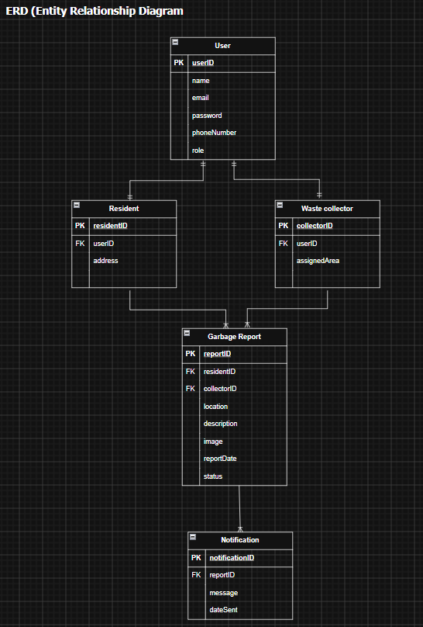

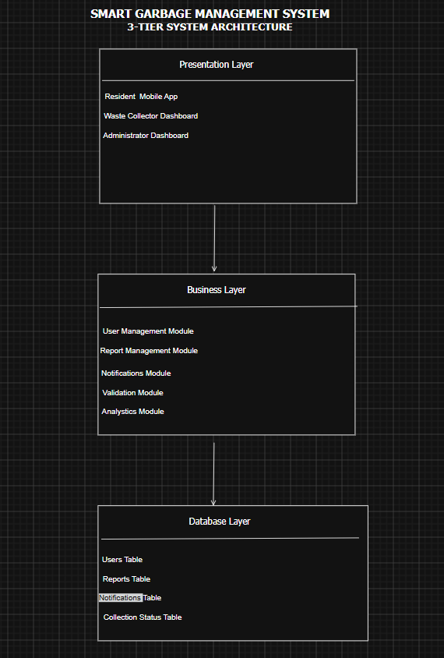

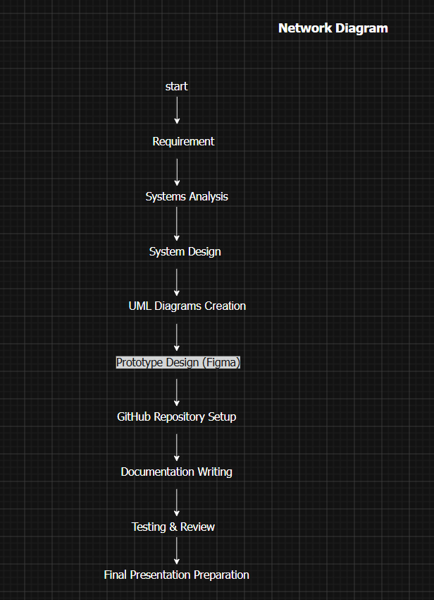

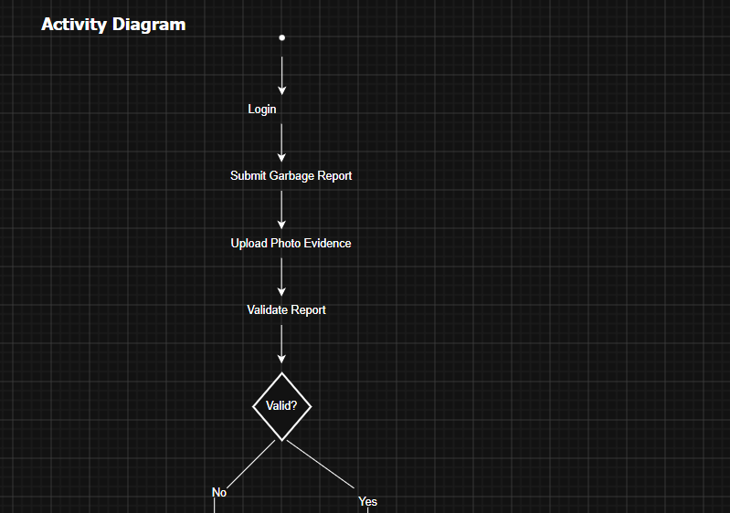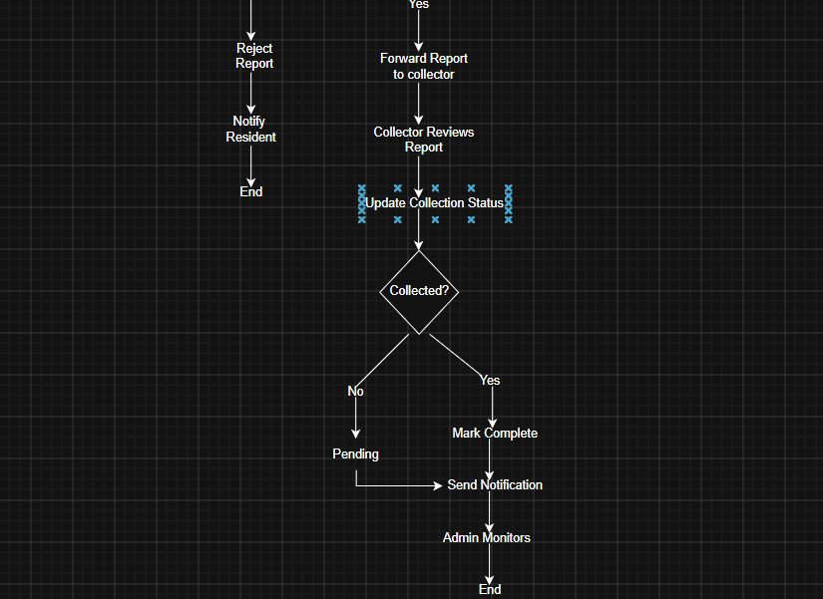

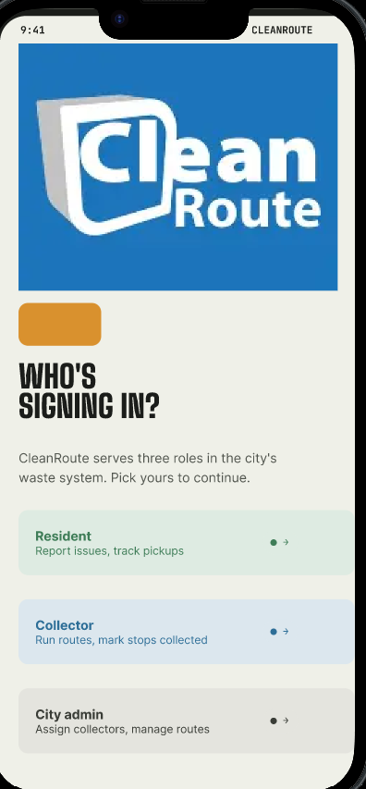

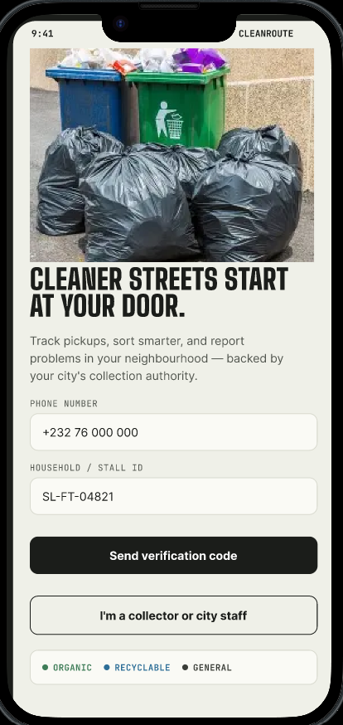

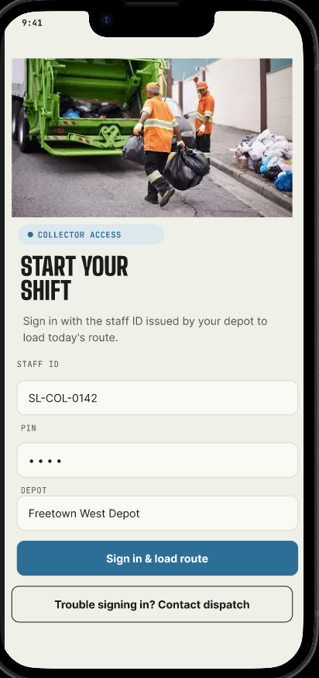

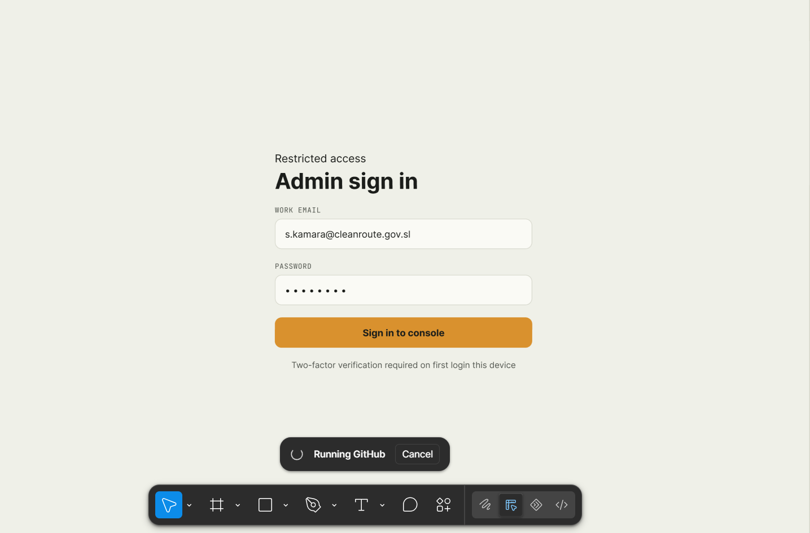

Conclusion
The Smart Garbage Management System provides an innovative approach to waste management by integrating digital technologies into garbage reporting and collection processes. Through effective communication, task management, and monitoring capabilities, the system contributes to cleaner communities, improved public health, and sustainable urban development.

